**VUFORIA CLOUD RECOGNITION in UNITY3D**



Technology has touched all aspects of our lives. Technology has had a huge impact on the quality of life that we lead in the modern age. From educational sector to healthcare sector all sectors benefitted hugely due to the advancement in technology. A lot of technologies have been used in these sectors. Augmented Reality is one such emerging technology that has huge promises. Augmented Reality is the real time direction of the existing reality and physical objects to trigger the enhancements over the reality, like images or 3D objects. AR is closer to the real-world objects. Basically, AR generates user selected images, videos, 3D objects and information into the real environment which can be viewed through the camera of the devices.

The best-known examples are BBC civilisations AR, Pokemon Go, IKEA replace and Sketchar. For example, Pokemon Go uses GPS to mark your location and move your in-game avatar, while your smartphone camera is used to show Pokémon in the real world. AR enhances the user’s perception of interaction with the real world. AR augments the user defined image target alongside the coordinates where next images, videos or objects can be transformed.

Vuforia is an Augmented Reality Software Development Kit for mobile devices to create AR applications. Vuforia has lots of funtions like 2D marker tracking, 3D object and model tracking, multi target tracking, text tracking, VuMark, cloud database based tracking and now ArCore and ARkit supports. Vuforia supports the Android, IOS and Universal Windows Platform Smart Glasses Hololens platforms and it has free and paid versions. Free version is limited for some functions and user amount; and $499 one-time fee or $99 for monthly for advanced funtions.

Now lets talk about Unity3D and then start a Vuforia project. Unity3D is one of the most popular game engine for amateur and professional developers and studios. Unity3D is orginally designed for 3D game making with de-facto standarts , low cost and easy of use, but after Unity 4.3, it is also possible to create 2D games and applications. Unity is very flexible and powerful for creation multiplatform games and applications. There are so many platforms that you can deploy to with the Unity3D like Android, IOS, Windows, Universal Windows Platfrom, Mac, Linux, WebGL, PlayStation 4, PSVita, Xbox, Nintendo, Oculus Rift and more. Unity is a “One code-based for all platforms” or “Build once Deploy Anywhere” game engine. It means, you can create the project ones and build to all platforms.

#### IMPLEMENTATION AUGMENTED REALITY IN UNITY3D WITH VUFORIA

**Before Starting**

* Before starting, you need a Vuforia Developer Account. From <https://developer.vuforia.com/vui/auth/register> register to free. If you have already an account, login to developer portal.
* If you use the last version of Vuforia SDK, you need version 2017.2 of Unity3D. If you don’t have this version or higher, you can download it <https://unity3d.com/get-unity/download>
* Now we need Vuforia SDK. (If you already have the SDK skip this step) If you don’t have Vuforia SDK and you use Unity version 2017.2 or higher you can install the SDK with using Unity Installer. You can get the installer here. <https://unity3d.com/get-unity/download/archive> Choose your Unity version and select the Unity Installer

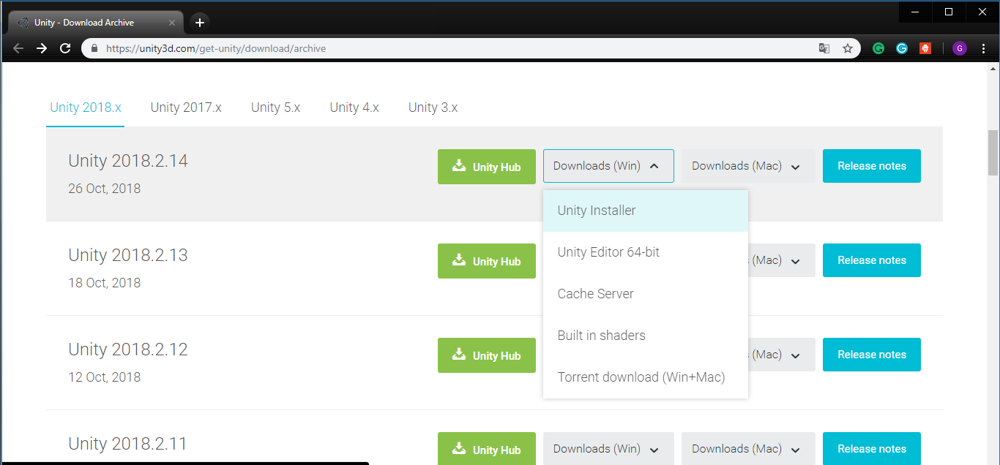

* Open the installer and choose components. We are going to make an app on Android platform so we need to Android Build Support. Also Vuforia Augmented Reality Support of course, dont forget it.

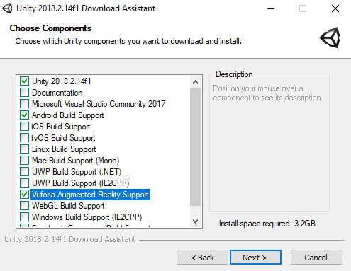

* If you use other version of Unity(lower than 2017.2) you need to download the Vuforia UnityPackage from here but we recommend downloading the latest version of Unity3D. <https://developer.vuforia.com/downloads/sdk?d=windows-30-16-4815&retU#downloadModal>

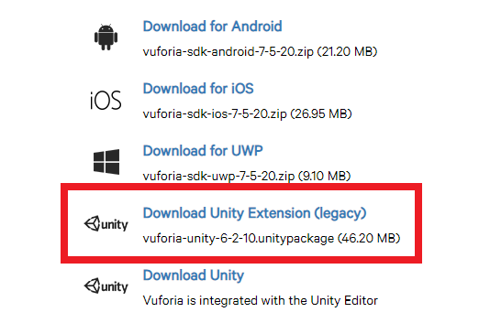



* If everything is fine lets open New Unity Project. Open Unity3D and click New button that is at the right top. And write your project name and choose the project location. Click CreateProject button to create the project and open it.

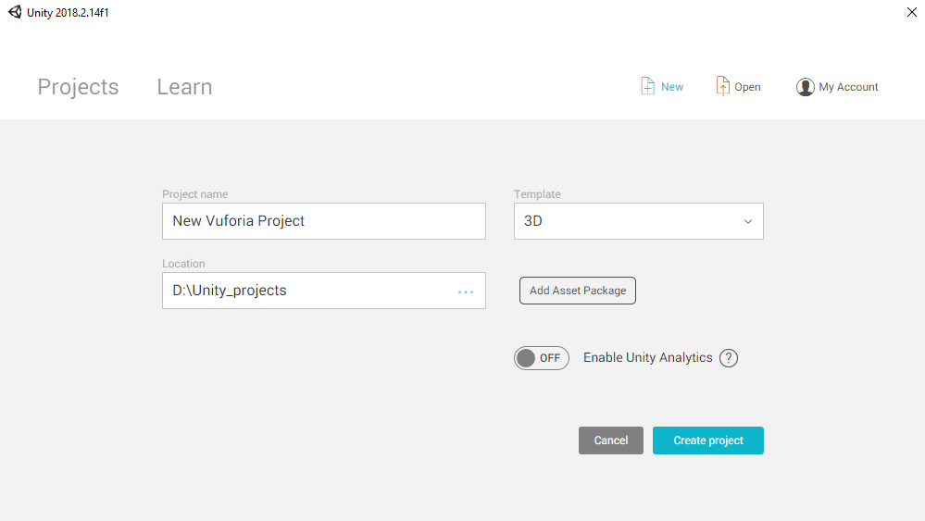

* After opening the project, we need to change some settings.
  + First of all is Platform. As I said Unity3D is a multi-platfotm game engine and you can build your project on so many platforms. We are developing a Android application so we need to change platform from PC to Android. Go “File > Build Settings” Select the Android option and click the Switch Platform. If you dont have Android Support Module, there will be a download option to download it but we did it at the beginning of installaiton using Download Asistant. (If you are new in Android platform, you also JDK and Android SDK to build Android. Go “Edit > Preferences > External tools” and set locations of these development kits).

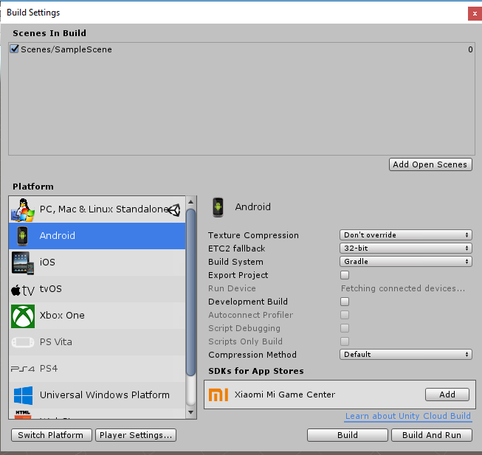

* + Second setting is Vuforia Support. Go “Edit > Project Settings > Playe” and check the Vuforia Support box under XR Settings.

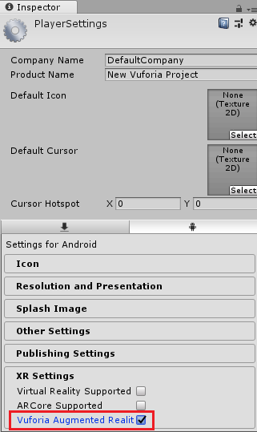

* Perfect, Finally we can start the developed our game. First we need “Development License Key”. It is free. Open the Vuforia Developer Console. (Login your account)

<https://developer.vuforia.com/targetmanager/licenseManager/licenseListing>

Click “Get Development Key”

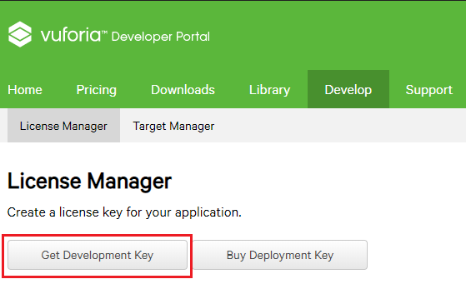

* Enter your Application name and Confirm

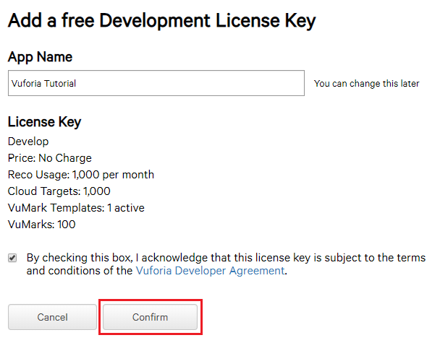

* Select your Application

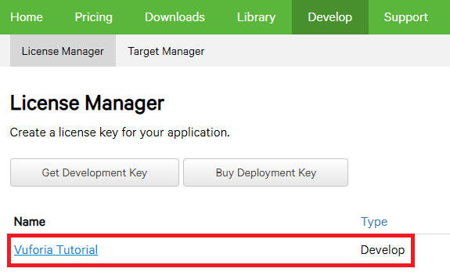

* Copy the licence key. We use this in Unity.

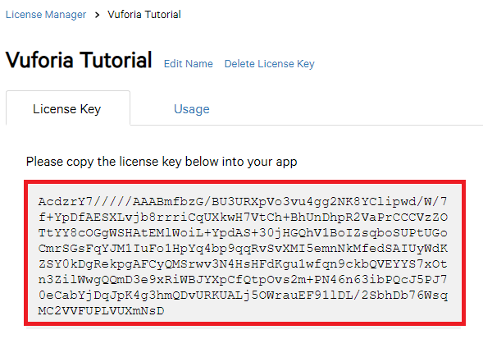

* Now go back to Unity and then Window -> Vuforia Configuraions (Ctrl + Shift + V) And paste the license key that you copied previous step.

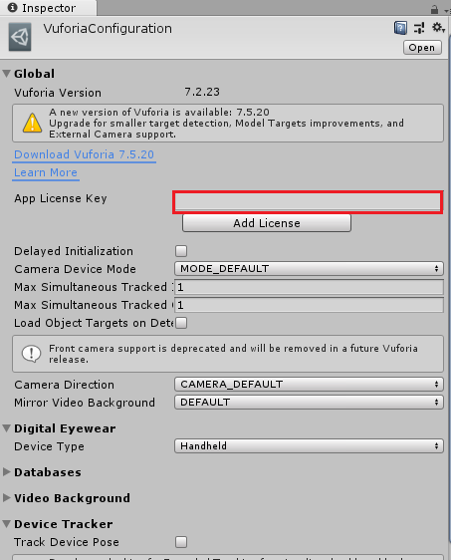

* Open the Vuforia Developer Portal again and go Target Manager to add images that are recognized by the application  
  <https://developer.vuforia.com/targetmanager/project/checkDeviceProjectsCreated>
* Click the “Add Database” to create a new Database

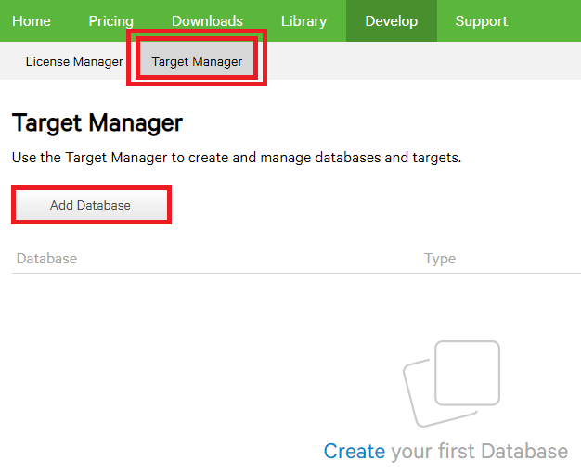

* Set the database name as that you want. And choose Cloud option and Select your License Key and Click Create

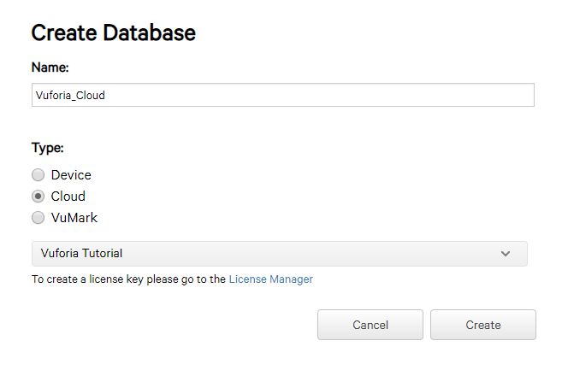

* Choose your database and click “Add Target”. Then Browse the image file. Format of the image must be .jpg or .png and it must be max 2mb.Set the width to 1 and if you want change the name. Select the Metadata file. The meta data file is that we can access and read it when the app recognize the image.It can be a .txt file. After all, click to “Add” 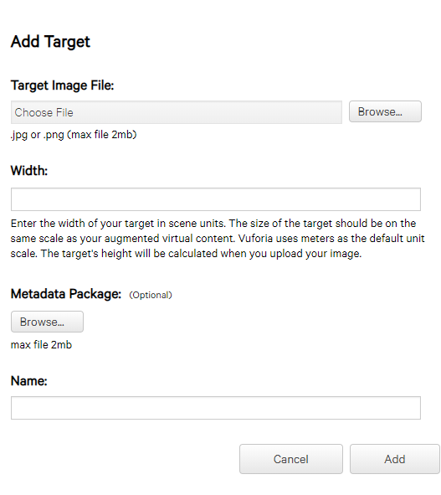
* Now get the Database Access Keys. Click this section.

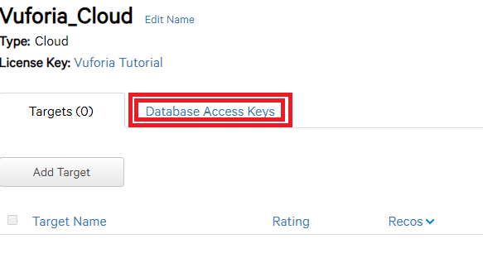

* Now open Unity again. Remove the Main Camera because we use an ARCamera. Create a new AR Camera by using the GameObject > Vuforia > AR Camera menu. And we need a provider is called “Cloud Provider”. Go GameObject > Vuforia > Cloud Provider. Open Vuforia Developer Portal and copy the “Client Access Key” and paste to Access Key of Cloud Provider and copy the “Client Secret Key” and paste to Secret Key of Cloud Provider.

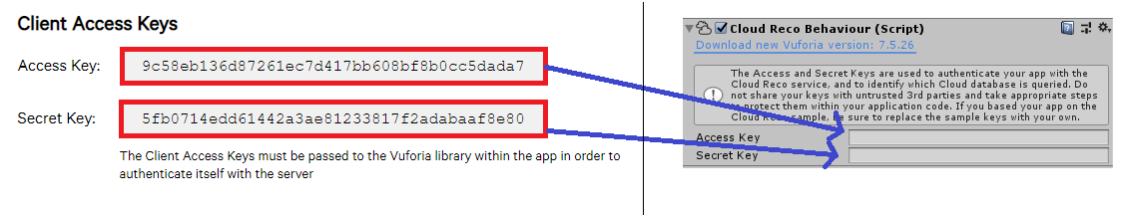

* Now we need one more thing. It is an image target. Go GameObject > Vuforia > Cloud Image > Cloud Image Target.

OK. We completed the basic things. Now we need to write some codes.

**Lets Write Code**

What will happens when the Cloud Provider recognizes an image?

* + - We need to create a new image target and do what we want to do.

What are we going to do?

* + - We are going to take a name(string) using meta data of the recognized image and show a prefab that has same name with the name(string) came form meta data.

How are we going to this?

* + - Writting Code.

Lets CODE

* Create a C# script called SimpleCloudHandler.cs. And attach the script to the CloudRecognition in your scene. Use this code. You download it here:::

//////////////// USE THIS CODEEEEEEEEEEEEEEEEEEEEEE

Or download in here /////////// link   
//////////////////////////

Reference the Image Target Template with the image target(in the hierarchy) that we created.

* Create a C# script called CreatePrefab and attach the script to the ImageTarget in your scene. Use this code or download here.

/////////////////////////////////////////////////////////////////////////////  
///////////////////////////////////////////////////////////

What do we in SimpleCloudHandler class?

* + - When the image is recognized, we create a new image target and we take the name/String form meta data in OnNewSearcResult method. And then we set the prefab name is defined in CreatePrefab class.

What do we in CreatePrefab class?

* + - The image target that is created by SimpleCloudHandler will activated and CreatePrefab class select the prefab that has same name with prefabName string that was set by SimpleCloudHandler in OneNewSearchResult. And the prefab will created by this class.

Which prefab can be selected?

* + - You need to attach the prefabs that you want to display with the PrefabList associated with ImageTarget

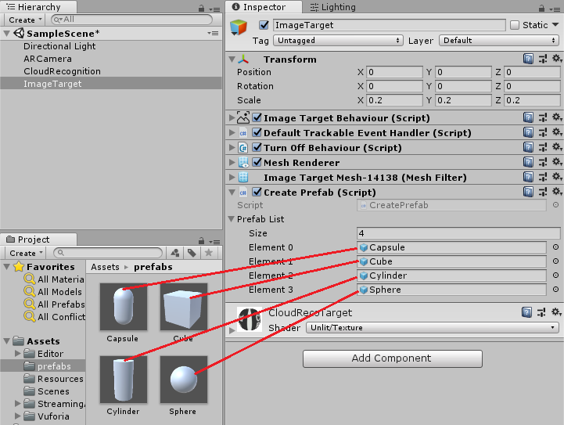

Most **importtant** thing :

The prefabs name must be same with the string that in the metadata file.

* Save the project and build.

ENJOY THE RESULT!!!

You can access the project files in here.